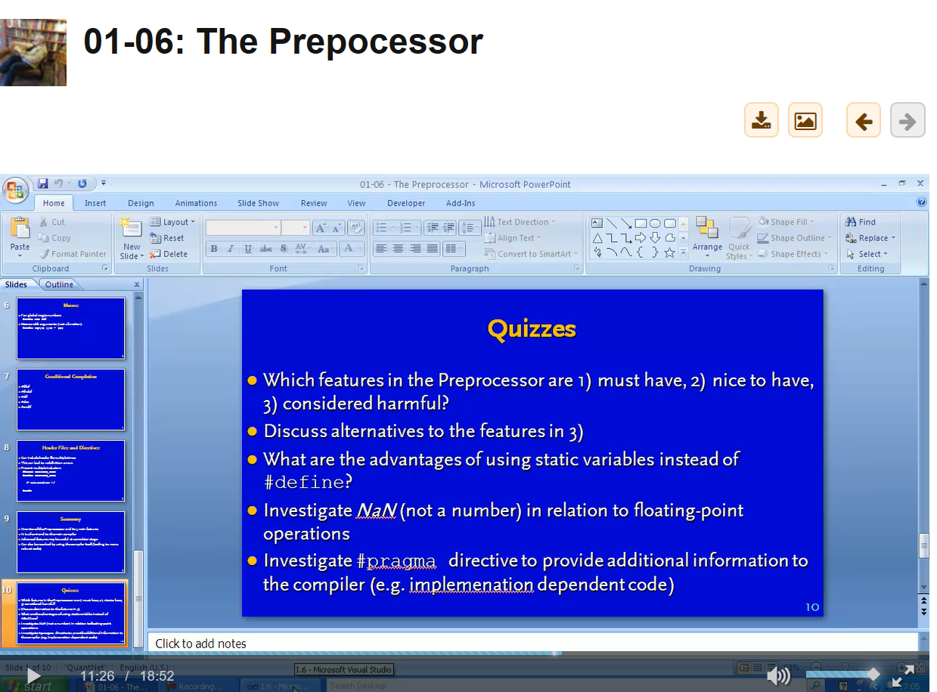

Can you actually generate a NaN, such a divide by zero.

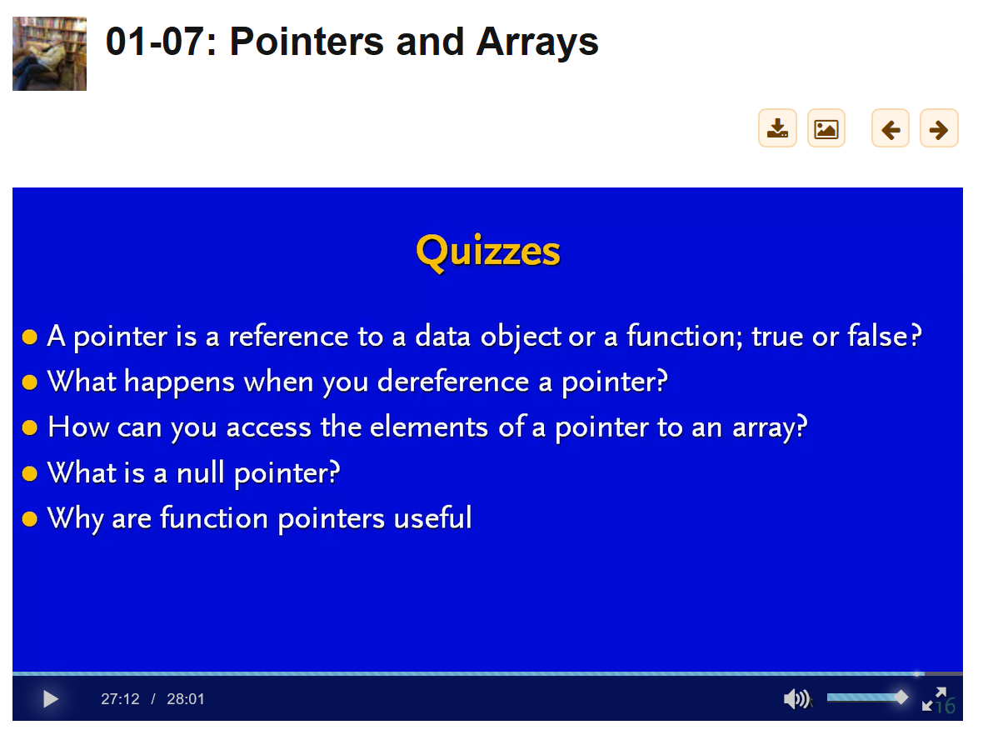

For 1-8, make sure to understand structs and typedef

Heap memory:

Stdlib.h 🡪 Use malloc() and then free()

File i/o – skip from 01-09

Worry about malloc() and then free()

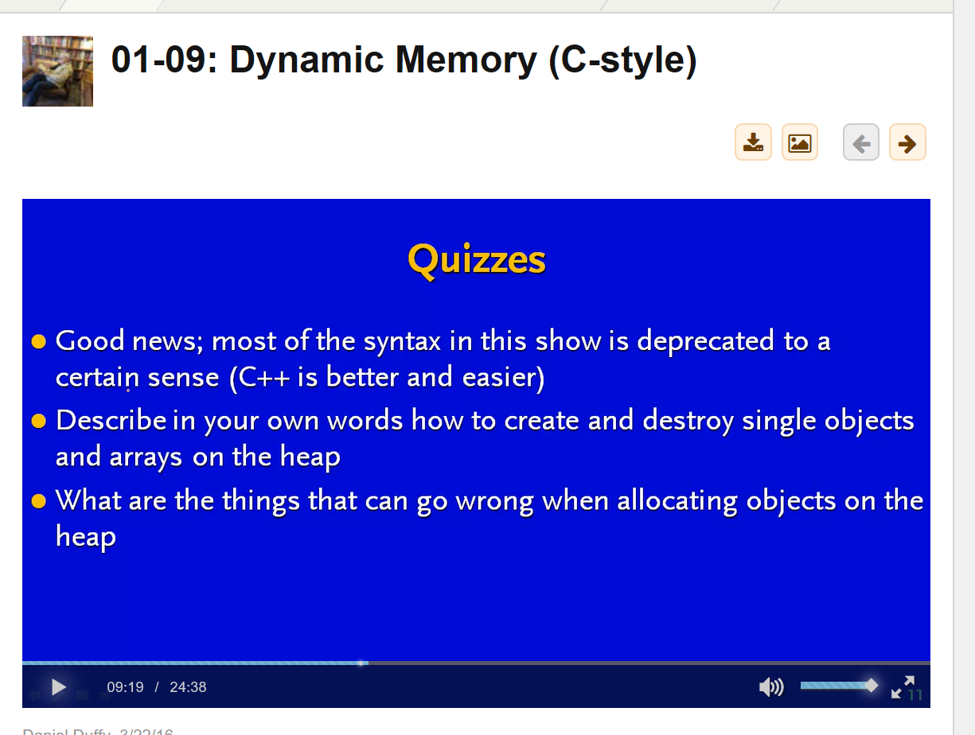

How to create – use malloc and then use free to destroy

Last question – forget to free memory (dangling memory), loose connection to a pointer